http://www.USScouts.Org • http://www.MeritBadge.Org
Please submit errors, omissions, comments or suggestions about this checklist to: Workbooks@USScouts.Org
Comments or suggestions for changes to the requirements should be sent to: Advancement.Team@Scouting.Org
Cub Scout’s Name: Pack No. :
Source for requirements: Cub Scout Webelos Handbook (#34754 - SKU 646430)
This adventure is an elective adventure which can be used to earn the Webelos and Arrow of Light Badges.

Complete Requirements 1-4 and one other.
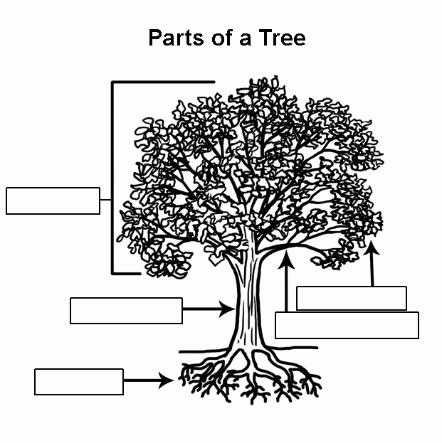
1. Identify two different groups of trees and the parts of a tree.
1.
2.
2. Identify four trees common to the area where you live. Tell whether they are native to your area. Tell how both wildlife and humans use them.

3. Identify four plants common to the area where you live. Tell which animals use them and for what purpose.

4. Develop a plan to care for and then plant at least one plant or tree, either indoors in a pot or outdoors.
Tell how this plant or tree helps the environment in which it is planted and what the plant or tree will be used for.
5. Make a list of items in your home that are made from wood and share it with your den.
Or with your den, take a walk and identify useful things made from wood.

6. Explain how the growth rings of a tree trunk tell its life story.
Describe different types of tree bark and explain what the bark does for the tree.
7. Visit a nature center, nursery, tree farm, or park, and speak with someone knowledgeable about trees and plants that are native to your area.
Where did you go?
Who did you speak with?

Explain how plants and trees are important to our ecosystem and how they improve our environment.
When working on Cub Scout Advancements and awards, Cub Scouts, their parents, and Scouters should be aware of some vital information in the current edition of the Guide to Advancement (BSA publication 33088).Important excerpts from that publication can be downloaded from http://usscouts.org/advance/docs/GTA-Excerpts-Cub.pdf.
You can download a complete copy of the Guide to Advancement .from http://www.scouting.org/filestore/pdf/33088.pdf.

