1. Safety. Do the following:
a. Show your counselor your current,Cyber Chip.
b. Explain to your counselor the most likely hazards you may encounter while working with photography and what you should do to anticipate, mitigate, prevent, and respond to these hazards.
Explain how you would prepare for exposure to environmental situations such as weather, sun, and water.

2. Explain how the following elements and terms can affect the quality of a picture:
a. Light—natural light (ambient/existing), low light (such as at night), and artificial light (such as from a flash)
Natural light
(ambient/existing):
low light
(such as at night
artificial light
(such as from a flash)
b. Exposure-aperture (f-stops), shutter speed, ISO
Aperture (f-stops):
Shutter speed:
ISO
c. Depth of field
d. Composition-rule of thirds, leading lines, framing, depth
Rule of thirds:
Leading lines:
Framing:
Depth:
e. Angle of view
f. Stop action and blur motion
Stop Action
Blur motion

g. Decisive moment (action or expression captured by the photographer)
3. Explain the basic parts and operation of a camera
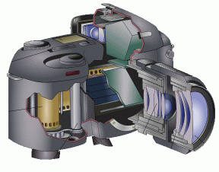
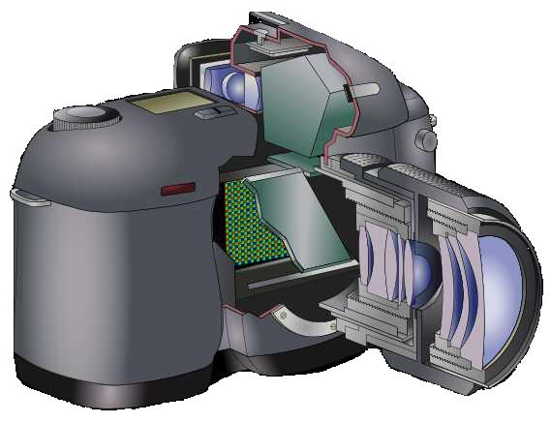
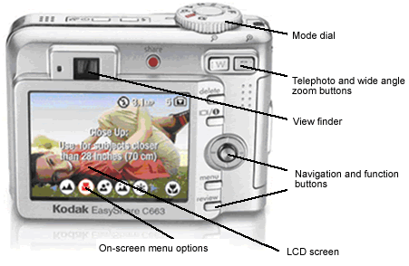 | 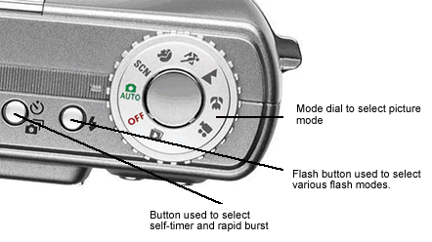
Explain how an exposure is made when you take a picture.
4. Do TWO of the following, then share your work with your counselor.
a. Photograph one subject from two different angles or perspectives.
b. Photograph one subject from two different light sources—artificial and natural.
c. Photograph one subject with two different depths of field.
d. Photograph one subject with two different compositional techniques.
5. Photograph THREE of the following, then share your work with your counselor
a. Close-up of a person
b. Two to three people interacting
c. Action shot
d. Animal shot.
e. Nature shot
f. Picture of a person—candid, posed, or camera aware
6. Describe how software allows you to enhance your photograph after it is taken.
Select a photo you have taken, then do ONE of the following, and share what you have done with your counselor.
a. Crop your photograph.
b. Adjust the exposure or make a color correction.
c. Show another way you could improve your picture for impact
7. Using images other than those created for requirements 4, 5 and 6, produce a visual story to document an event to photograph OR choose a topic that interests you to photograph. Do the following:
a. Plan the images you need to photograph for your photo story.
b. Share your plan with your counselor, and get your counselor's input and approval before you proceed.
c. Select eight to 12 images that best tell your story. Arrange your images in order and mount the prints on a poster board, OR create an electronic presentation. Share your visual story with your counselor.

8. Identify three career opportunities in photography.
1.
2.
3.

Pick one
and explain to your counselor how to prepare for such a career.
Discuss what education and training are required, and why this profession might interest you.
When working on merit badges, Scouts and Scouters should be aware of some vital information in the current edition of the Guide to Advancement (BSA publication 33088). Important excerpts from that publication can be downloaded from http://usscouts.org/advance/docs/GTA-Excerpts-meritbadges.pdf.
You can download a complete copy of the Guide to Advancement from http://www.scouting.org/filestore/pdf/33088.pdf.

http://www.USScouts.Org • http://www.MeritBadge.Org
Please submit errors, omissions, comments or suggestions about this workbook to: Workbooks@USScouts.Org
Comments or suggestions for changes to the requirements for the award should be sent to: Advancement.Team@Scouting.Org
A. Cyber Chip Requirements for Grades 6-8
1. Read and sign the Level II Internet Safety Pledge on the BSA Cyber Chip card. (BSA Cyber Chip green card; can be ordered at www.scoutshop.org.)
Internet Safety Pledge
1. I will think before I post
2. I will respect other people online
3. I will respect digital media ownership
4. I won't meet face-to-face with anyone I meet in the digital world unless I have my parent's permission
5. I will protect myself online.
2. Write and sign a personalized contract with your parent or guardian that outlines rules for using the computer and mobile devices, including what you can download, what you can post, and consequences for inappropriate use.
General comments
What I can download
What I can post
Consequences for inappropriate use
3. Watch the video “Friend or Fake” (www.nsteens.org/Videos/FriendOrFake), along with two additional videos of your choosing (www.nsteens.org/Videos/FriendOrFake) {from the list below}, to see how friends can help each other to stay safe online.
- Post to be Private (youtu.be/mBsoODqfQgA)
- Split Decisions (youtu.be/HLUv8DHt_R4)
- Two Kinds of Stupid (youtu.be/T6ulH2bWCnY)
 | Video Name | Date Watched
 | Friend or Fake?
4. As an individual or with your patrol, use the EDGE method to teach internet safety rules, behavior, and “netiquette” to your troop or another patrol. You are encouraged to use any additional material and information you have researched. Each member of the patrol must have a role and present part of the lesson.
5. Discuss with your unit leader the acceptable standards and practices for using allowed electronic devices, such as phones and games, at your meetings and other Scouting events.

B. Cyber Chip Requirements for Grades 9-12
1. Read and sign the Level II Internet Safety Pledge on the BSA Cyber Chip card. (BSA Cyber Chip green card; can be ordered at www.scoutshop.org.)
Internet Safety Pledge
1. I will think before I post
2. I will respect other people online
3. I will respect digital media ownership
4. I won't meet face-to-face with anyone I meet in the digital world unless I have my parent's permission
5. I will protect myself online.
2. Write and sign a personalized contract with your parent or guardian that outlines rules for using the computer and mobile devices, including what you can download, what you can post, and consequences for inappropriate use.
General comments
What I can download
What I can post
Consequences for inappropriate use

3. Discuss with your parents the benefits and potential dangers teenagers might experience when using social media.
Give examples of each.
4. Watch three {of the following} “Real-Life Story” videos (www.nsteens.org/videos.aspx?Brand=Real-Life-Stories) to learn the impact on teens.
- Friend or Fake? (youtu.be/Nb1zAY_cc8o)
- Post to be Private (youtu.be/mBsoODqfQgA)
- Split Decisions (youtu.be/HLUv8DHt_R4)
- Two Kinds of Stupid (youtu.be/T6ulH2bWCnY)
 | Video Name | Date Watched
5. As an individual or patrol, use the EDGE method and the Student Project Kit www.missingkids.org/content/dam/netsmartz/downloadable/studentprojectkit/Student_Project_Kit_V1.5.pdf) to teach internet safety rules, behavior, and “netiquette” to your troop or another patrol. You are encouraged to use any additional material and information you have researched. Each member of the patrol must have a role and present part of the lesson.
6. Discuss with your unit leader the acceptable standards and practices for using allowed electronic devices such as phones and games at your meetings and other Scouting events.
Note: All Cyber Chips will expire annually. Each Scout will need to go to Netsmartz (www.netsmartz.org) and complete two new resources to recommit to net safety and netiquette. Then, with the unit leader, the Scout can add the new date to the Cyber Chip card or certificate.

Editor’s Note: The text in this form is additional material which is found on the scouting.org website, that does not appear in the 2020 Scouts BSA Requirements booklet (33216 - SKU 653801).
When working on merit badges, Scouts and Scouters should be aware of some vital information in the current edition of the Guide to Advancement (BSA publication 33088). Important excerpts from that publication can be downloaded from http://usscouts.org/advance/docs/GTA-Excerpts-meritbadges.pdf.
You can download a complete copy of the Guide to Advancement from http://www.scouting.org/filestore/pdf/33088.pdf.

