http://www.USScouts.Org • http://www.MeritBadge.Org
Please submit errors, omissions, comments or suggestions about this workbook to: Workbooks@USScouts.Org
Comments or suggestions for changes to the requirements for the Belt Loop or Pin should be sent to: Advancement.Team@Scouting.Org
Cub Scout’s Name: Pack No. :

Webelos Scouts that earn the Geography Belt Loop while a Webelos Scout
also satisfy requirement 12 for the Traveler Activity Badge..
(Editor’s Note: You can use the world maps or the US maps
included at the end of this worksheet for many of the requirements.)

Cub Scout Geography Belt Loop (See the Pin Requirements below.)
Complete these three requirements:
1. Draw a map of your neighborhood. Show natural and manmade features. Include a key or legend of map symbols.
2. Learn about the physical geography of your community. Identify the major landforms within 100 miles. Discuss with an adult what you learned.
3. Use a world globe or map to locate the continents, the oceans, the equator, and the northern and southern hemispheres. Learn how longitude and latitude lines are used to locate a site.

Cub Scout Geography Pin
Earn the Cub Scout Geography belt loop, and complete five of the following requirements:
. 1. Make a 3-D model of an imaginary place. Include five different landforms, such as mountains, valleys, lakes, rivers, plateaus, and plains.
2. List 10 cities around the world. Calculate the time it is in each city when it is noon in your town.
 | City | Time |  | City | Time
1. |  |  | 6.
2. |  |  | 7.
3. |  |  | 8.
4. |  |  | 9.
5. |  |  | 10.
3. Find the company's location on the wrapper or label of 10 products used in your home, such as food, clothing, toys, and appliances.
 | Product | Company | Location
1.
2.
3.
4.
5.
6.
7.
8.
9.
10.
Use a world map or atlas to find each location.
4. On a map, trace the routes of some famous explorers. Show the map to your den or family.
5. On a United States or world map, mark where your family members and ancestors were born.
6. Keep a map record of the travels of your favorite professional sports team for one month.
7. Choose one:
a. Read a book in which geography plays an important part
b. On a web site with satellite views of earth, identify at least five locations, including your home address or a nearby building. Be sure you have your parent's or adult partner's permission first.
1.
2.
3.
4.
5.
8. Take part in a geography bee or fair in your pack, school, or community.
9. Choose a country and make a travel poster for it.
10. Play a geography-based board game or computer game. Tell an adult some facts you learned about a place that was part of the game.
Game:
11. Draw or make a map of your state. Include rivers, mountain ranges, state parks, and cities. Include a key or legend of map symbols.
Requirement resources can be found here:
http://www.meritbadge.org/wiki/index.php/Cub_Scout_Geography#Requirement resources

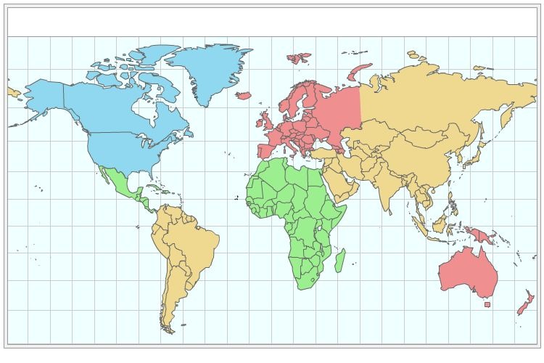
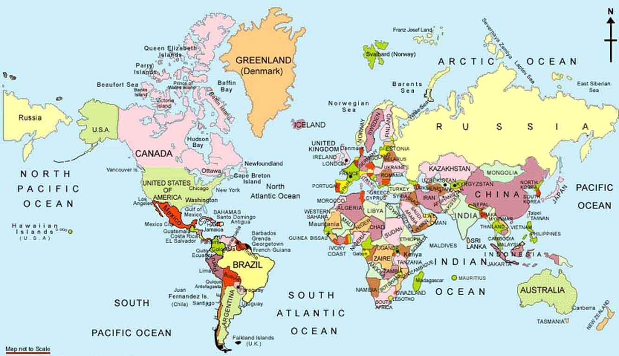
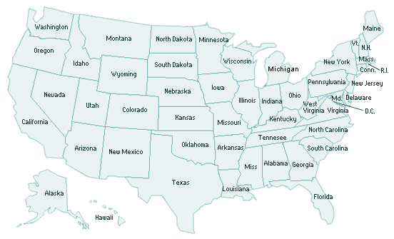
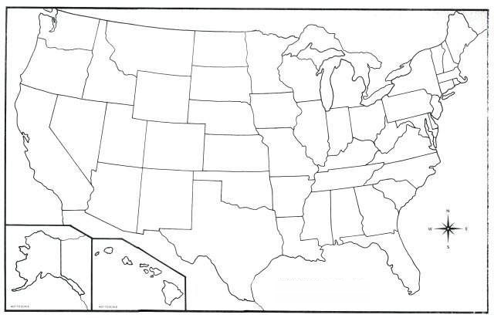

Important excerpts from the ‘Guide To Advancement’, No. 33088:
Effective January 1, 2012, the ‘Guide to Advancement’ (which replaced the publication ‘Advancement Committee Policies and Procedures’) is now the official Boy Scouts of America source on advancement policies and procedures.
- [ Inside front cover, and 5.0.1.4 ] — Unauthorized Changes to Advancement Program
No council, committee, district, unit, or individual has the authority to add to, or subtract from, advancement requirements. (There are limited exceptions relating only to youth members with disabilities. For details see section 10, “Advancement for Members With Special Needs”.)
- [ Inside front cover, and 7.0.1.1 ] — The ‘Guide to Safe Scouting’ Applies
Policies and procedures outlined in the ‘Guide to Safe Scouting’, No. 34416, apply to all BSA activities, including those related to advancement and Eagle Scout service projects. [Note: Always reference the online version, which is updated quarterly.]
- [ 4.1.0.3 ] ] — Who Approves Cub Scout Advancement?
A key responsibility for den leaders is to implement the core den meeting plans as outlined in the Den & Pack Meeting Resource Guide, No. 34409. For Wolf, Bear, and Webelos advancement, den leaders take the lead in approving requirements, though their assistants, and also parents who help at meetings, may be asked to play the role of “Akela” and assist. Parents sign for requirements that, according to meeting plans and instructions in the handbooks, take place at home. For the Bobcat trail and Tiger Cub achievements, parents (or adult partners) should sign in the boy’s handbook; the den leader then approves as progress is recorded in the den’s advancement record.
- [ 4.1.0.4 ] — “Do Your Best”
Advancement performance in Cub Scouting is centered on its motto: “Do Your Best.” When a boy has done this—his very best—then regardless of the requirements for any rank or award, it is enough; accomplishment is noted. This is why den leaders, assistants, and parents or guardians are involved in approvals. Generally they know if effort put forth is really the Cub Scout’s best.
- [ 4.1.2.2 ] — Cub Scout Academics and Sports Program
More than just a recognition opportunity, this program develops new skills, improves those existing, and otherwise enriches Cub Scouting. Details can be found in the Cub Scout Academics and Sports Program Guide, No. 34299. Activities include subjects like science, video games, collecting, and chess; and sports such as baseball, skateboarding, and table tennis. Each has two levels—a belt loop and a pin. Belt loops, which can be earned more than once, are awarded when each of three requirements is met. Cub Scouts may then continue with additional requirements and earn the pin. Archery and BB gun shooting are included, but can only be conducted at a council presented activity with certified supervisors.
Additional notes of interest:
- Tiger Cubs, Cub Scouts, and Webelos Scouts may complete requirements for all Academics and Sports Belt Loops and Pins (except shooting sports) in a family, den, pack, school, or community environment. Tiger Cubs must work with their parents or adult partners. Parents and partners do not earn loops or pins.
- “Akela” (Pronounced “Ah-KAY-la”) — Title of respect used in Cub Scouting—any good leader is Akela. Akela is also the leader and guide for Cub Scouts on the advancement trail. The name comes from Rudyard Kipling's Jungle Book. (See "Law of the Pack.")
- “Law of the Pack” — The Cub Scout follows Akela.
The Cub Scout helps the pack go.
The pack helps the Cub Scout grow.
The Cub Scout gives goodwill.

