http://www.USScouts.Org • http://www.MeritBadge.Org
Please submit errors, omissions, comments or suggestions about this workbook to: Workbooks@USScouts.Org
Comments or suggestions for changes to the requirements for the merit badge should be sent to: Merit.Badge@Scouting.Org
______________________________________________________________________________________________________________________________________________
1. Do the following:
a. Explain to your counselor the most likely hazards you may encounter while participating in athletics activities, and what you should do to anticipate, help prevent, mitigate, and respond to these hazards.
Hazards:
What you should do:
b. Show that you know first aid for injuries or illnesses that could occur while participating in athletic events, including sprains, strains, contusions, abrasions, blisters, dehydration, and heat reactions.
Sprains:
Strains:
Contusions:
Abrasions:
Blisters:
Dehydration:
Heat reactions:

2. Explain the following:
a. The importance of the physical exam
b. The importance of maintaining good health habits, especially during training - and how the use of tobacco products, alcohol, and other harmful substances can negatively affect your health and performance in athletic activities.
c. The importance of maintaining a healthy diet.
3. Select an athletic activity to participate in for one season (or four months.
Then do the following:
a. With guidance from your counselor, establish a personal training program suited to the activity you have chosen.
b. Organize a chart for this activity and monitor your progress during this time.
Date | Progress
c. Explain to the counselor the equipment necessary to participate in this activity, and the appropriate clothing for the season and the locale.
Equipment:
Clothing:
d. At the end of the season, discuss with your counselor the progress you have made during training and competition and how your development has affected you mentally and physically.
Progress:
Mental and Physical effects:
4. Do the following:
a. Give the rules for two athletic activities, one of which is the activity you chose for requirement 3.
Activity 1:
Rules:
Activity 2:
Rules:
b. Discuss the importance of warming up and cooling down.
Warming up:
Cooling down:
c. Explain to your counselor what an amateur athlete is and the differences between an amateur and a professional athlete.
Amateur:
Professional
Differences between amateur and professional:
d. Discuss the traits and importance of good sportsmanship.

Tell what role sportsmanship plays in both individual and group athletic activities.
Individual
Group
5. Complete the activities in FOUR of the following groups and show improvement over a three-month period.
Activities | Beginning | Three Months Later
Group 1: Sprinting
a. 100-meter dash
b. 200-meter dash
Group 2: Long-Distance Running
a. 3k run
b. 5k run
Group 3: Long Jump OR High Jump
a. Running long jump OR running high jump (best of three tries)
b. Standing long jump OR standing high jump (best of three tries)
Group 4: Swimming
a. 100-meter swim
b. 200-meter swim
Group 5: Pull-Ups AND Push-Ups
a. Pull-ups in two minutes
b. Push-ups in two minutes
Group 6: Baseball Throw
a. Baseball throw for accuracy, 10 throws
b. Baseball throw for distance, five throws (total distance)

Group 7: Basketball Shooting
a. Basketball shot for accuracy, 10 free-throw shots
b. Basketball throw for skill and agility, the following shots as shown on the diagram (on next page)
1. Left-side layup
2. Right-side layup
3. Left side of hoop, along the key line
4. Right side of hoop, along the key line
5. Where key line and free-throw line meet, left side
6. Where key line and free-throw line meet, right side
7. Top of the key
8. Anywhere along the three-point line.
Group 8: Football Kick OR Soccer Kick
a. Goals from the 10-yard line, eight kicks
b. Football kick or soccer kick for distance, five kicks (total distance)
Group 9: Weight Training
a. Chest/bench press, two sets of 15 repetitions each
b. Leg curls, two sets of 15 repetitions each
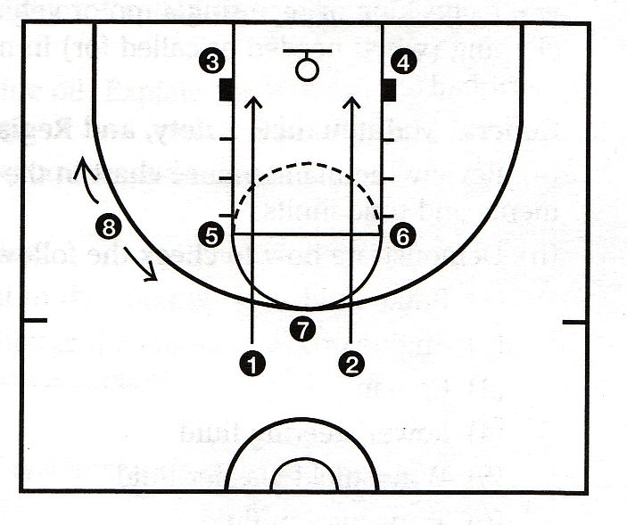

6. Do the following:
a. Prepare plans for conducting a sports meet or field day that includes 10 activities, at least five of which must come from the groups mentioned in requirement 5. Outline the duties of each official needed and list the equipment the meet will require.
b. With your parent's and counselor's approval, serve as an official or volunteer at a sports meet to observe officials in action. Tell your counselor about your responsibilities at the meet and discuss what you learned.
Requirement resources can be found here:
http://www.meritbadge.org/wiki/index.php/Athletics#Requirement resources

[1.0.0.0] — Introduction
The current edition of the Guide to Advancement is the official source for administering advancement in all Boy Scouts of America programs: Cub Scouting, Boy Scouting, Varsity Scouting, Venturing, and Sea Scouts. It replaces any previous BSA advancement manuals and previous editions of the Guide to Advancement.
[Page 2, and 5.0.1.4] — Policy on Unauthorized Changes to Advancement Program
No council, committee, district, unit, or individual has the authority to add to, or subtract from, advancement requirements. There are limited exceptions relating only to youth members with special needs. For details see section 10, “Advancement for Members With Special Needs”.
[Page 2] — The “Guide to Safe Scouting” Applies
Policies and procedures outlined in the Guide to Safe Scouting, No. 34416, apply to all BSA activities, including those related to advancement and Eagle Scout service projects.
[7.0.3.1] — The Buddy System and Certifying Completion
A youth member must not meet one-on-one with an adult. Sessions with counselors must take place where others can view the interaction, or the Scout must have a buddy: a friend, parent, guardian, brother, sister, or other relative—or better yet, another Scout working on the same badge—along with him attending the session. If merit badge counseling or instruction includes any Web-based interaction, it must be conducted in accordance with the BSA Social Media Guidelines (http://www.scouting.org/Marketing/Resources/SocialMedia). For example, always copy one or more authorized adults on email messages between counselors and Scouts.
When the Scout meets with the counselor, he should bring any required projects. If these cannot be transported, he should present evidence, such as photographs or adult verification. His unit leader, for example, might state that a satisfactory bridge or tower has been built for the Pioneering merit badge, or that meals were prepared for Cooking. If there are questions that requirements were met, a counselor may confirm with adults involved. Once satisfied, the counselor signs the blue card using the date upon which the Scout completed the requirements, or in the case of partials, initials the individual requirements passed.
Note that from time to time, it may be appropriate for a requirement that has been met for one badge to also count for another. See “Fulfilling More Than One Requirement With a Single Activity,” 4.2.3.6.
[7.0.3.2] — Group Instruction
It is acceptable—and sometimes desirable—for merit badges to be taught in group settings. This often occurs at camp and merit badge midways, fairs, clinics, or similar events. Interactive group discussions can support learning. The method can also be attractive to “guest experts” assisting registered and approved counselors. Slide shows, skits, demonstrations, panels, and various other techniques can also be employed, but as any teacher can attest, not everyone will learn all the material.
There must be attention to each individual’s projects and his fulfillment of all requirements. We must know that every Scout —actually and personally— completed them. If, for example, a requirement uses words like “show,” “demonstrate,” or “discuss,” then every Scout must do that. It is unacceptable to award badges on the basis of sitting in classrooms watching demonstrations, or remaining silent during discussions.
It is sometimes reported that Scouts who have received merit badges through group instructional settings have not fulfilled all the requirements. To offer a quality merit badge program, council and district advancement committees should ensure the following are in place for all group instructional events.
- A culture is established for merit badge group instructional events that partial completions are acceptable expected results.
- A guide or information sheet is distributed in advance of events that promotes the acceptability of partials, explains how merit badges can be finished after events, lists merit badge prerequisites, and provides other helpful information that will establish realistic expectations for the number of merit badges that can be earned at an event.
- Merit badge counselors are known to be registered and approved.
- Any guest experts or guest speakers, or others assisting who are not registered and approved as merit badge counselors, do not accept the responsibilities of, or behave as, merit badge counselors, either at a group instructional event or at any other time. Their service is temporary, not ongoing.
- Counselors agree to sign off only requirements that Scouts have actually and personally completed.
- Counselors agree not to assume prerequisites have been completed without some level of evidence that the work has been done. Pictures and letters from other merit badge counselors or unit leaders are the best form of prerequisite documentation when the actual work done cannot be brought to the camp or site of the merit badge event.
- There is a mechanism for unit leaders or others to report concerns to a council advancement committee on summer camp merit badge programs, group instructional events, and any other merit badge counseling issues—especially in instances where it is believed BSA procedures are not followed. See “Reporting Merit Badge Counseling Concerns,” 11.1.0.0.
- There must be attention to each individual’s projects and his fulfillment of all requirements. We must know that every Scout—actually and personally—completed them.
It is permissible for guest speakers, guest experts, or others who are not merit badge counselors to assist in the counseling process. Those providing such assistance must be under the direction of a registered and approved counselor who is readily available onsite, and provides personal supervision to assure all applicable BSA policies and procedures—including those related to BSA Youth Protection—are in place and followed.
[7.0.3.3] — Partial Completions
A Scout need not pass all the requirements of one merit badge with the same counselor. It may be that due to timing or location issues, etc., he must meet with a different counselor to finish the badge. The Application for Merit Badge has a place to record what has been finished—a “partial.” In the center section on the reverse of the blue card, the counselor initials for each requirement passed. In the case of a partial completion, the counselor does not retain his or her portion of the card. A subsequent counselor may choose not to accept partial work, but this should be rare. A Scout, if he believes he is being treated unfairly, may work with his unit leader to find another counselor. An example for the use of a signed partial would be to take it to camp as proof of prerequisites. Partials have no expiration except the Scout’s 18th birthday. Units, districts, or councils shall not establish other expiration dates for partial merit badges.
[7.0.4.8] — Unofficial Worksheets and Learning Aids
Worksheets and other materials that may be of assistance in earning merit badges are available from a variety of places including unofficial sources on the Internet and even troop libraries. Use of these aids is permissible as long as the materials can be correlated with the current requirements that Scouts must fulfill. Completing “worksheets” may suffice where a requirement calls for something in writing, but this would not work for a requirement where the Scout must discuss, tell, show, or demonstrate, etc. Note that Scouts shall not be required to use these learning aids in order to complete a merit badge.

